**Program no : 7**

**Program Title : PIR**

**Aim : The lights turns on if there is any motion in the range**

**Hardware Required :**

* Arduino Board
* LED
* PIR sensor
* Resistor

Circuit Diagram :

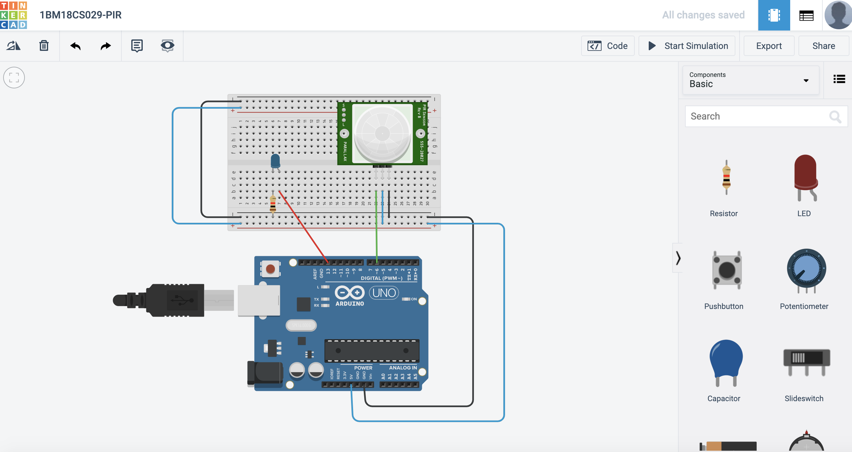

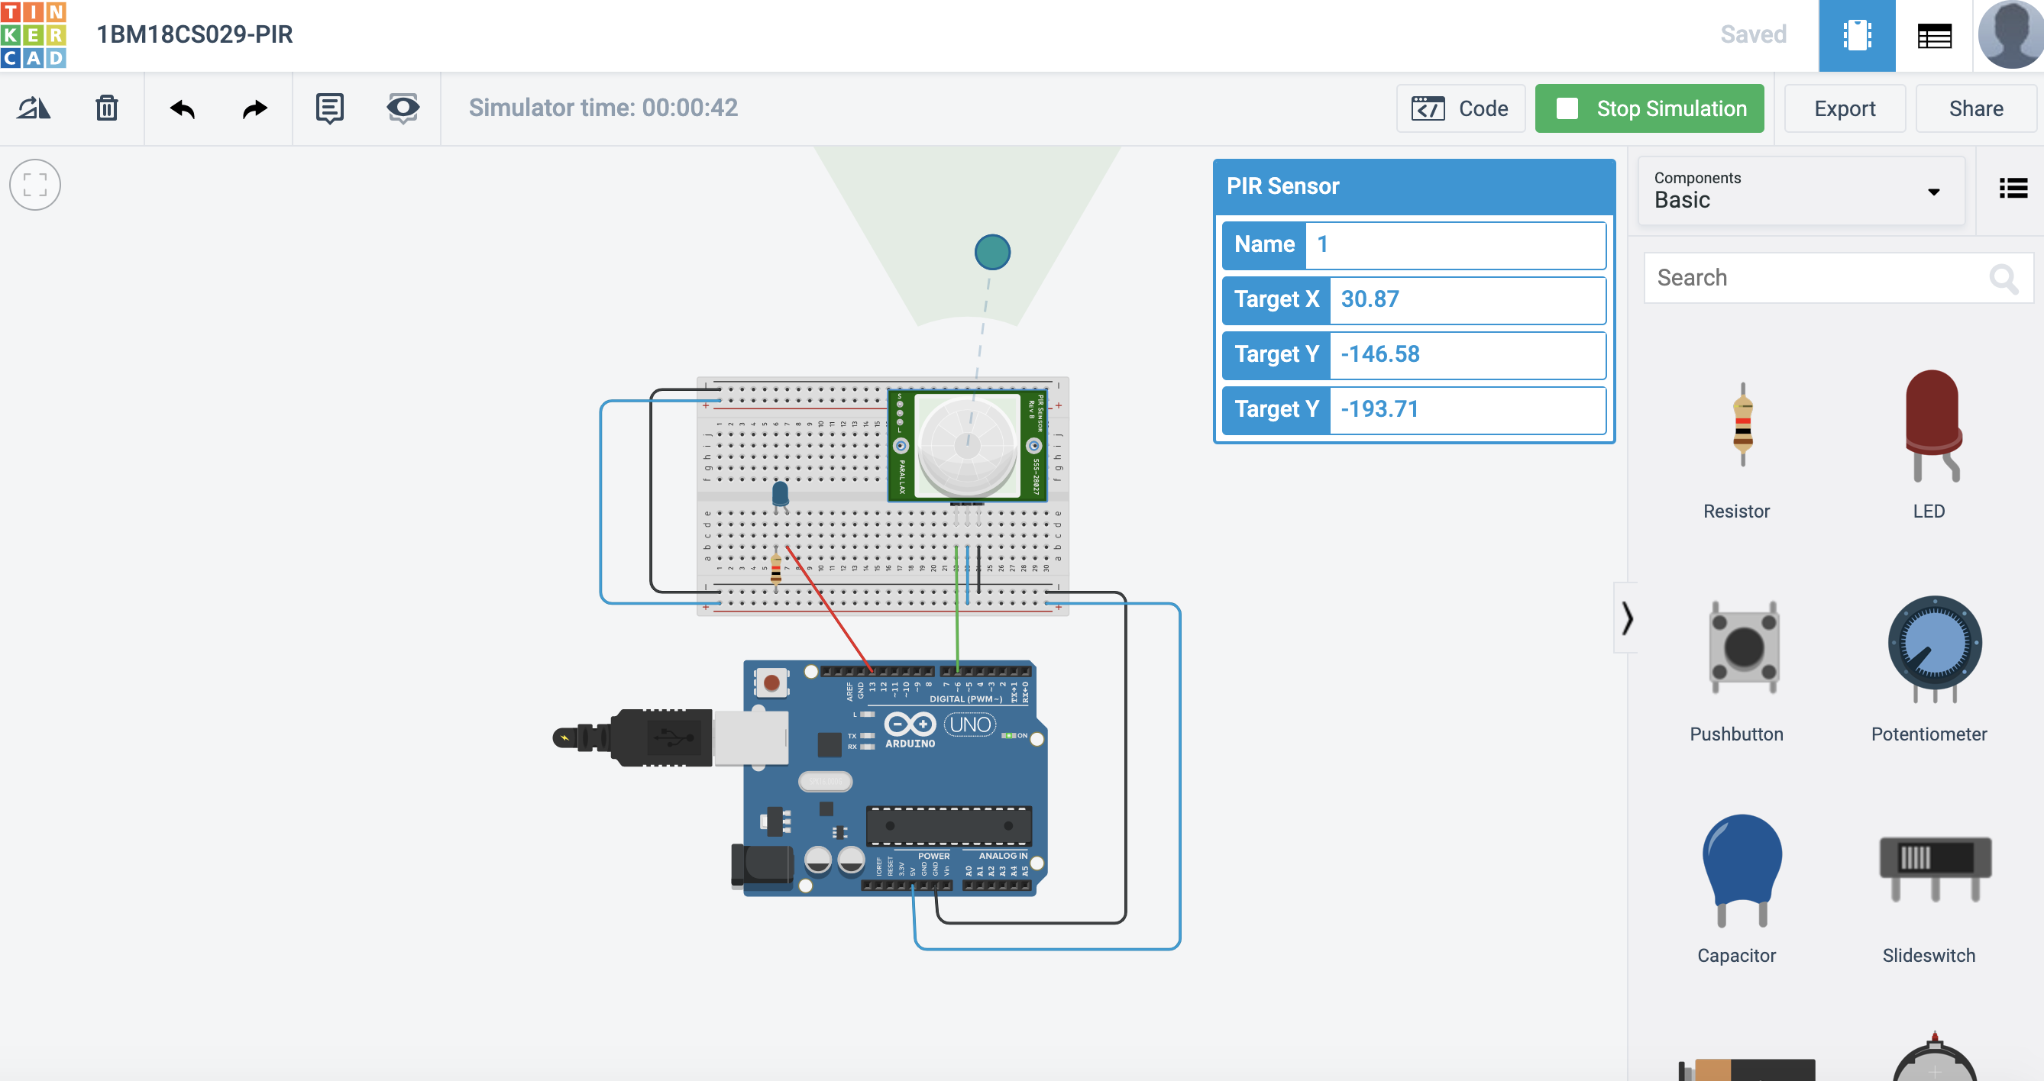

Code :

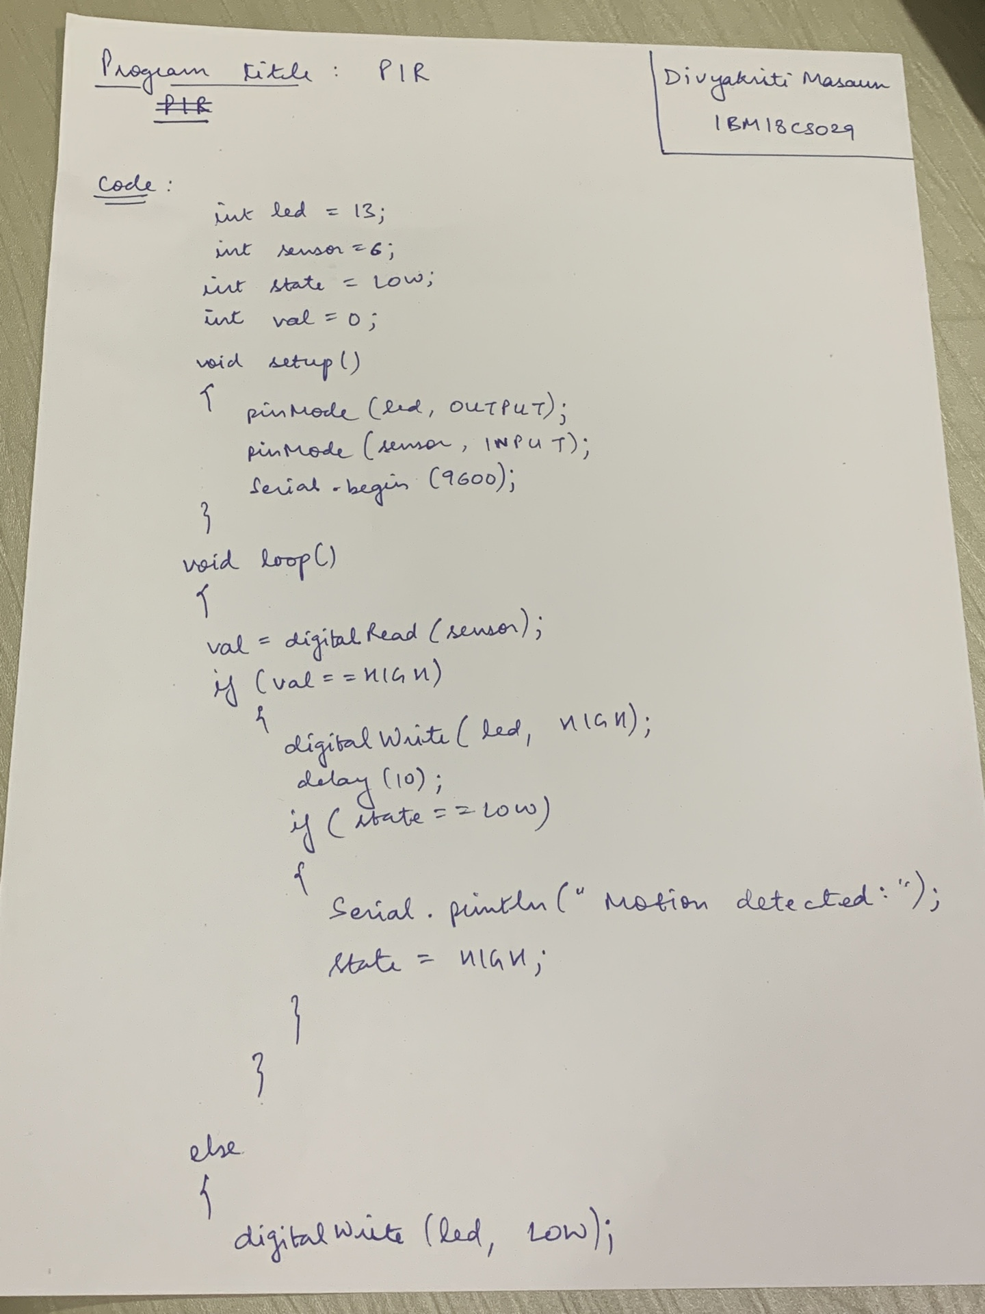

OUTPUT / OBSERVATION :

The lights automatically turn on if there is any motion detected in the range.